Dashboard and Story Report
Date | 31 January 2026
Team ID | LTVIP2026TMIDS28502
Project Name | Visualizing Housing Market Trends: An Analysis of Sale Prices and Features using Tableau

1. Dashboard Overview
The Tableau dashboard was created to provide an interactive visualization of housing market trends.
Dashboard Components:
- Total number of houses (KPI)
- Average sale price (KPI)
- Total basement area (KPI)
- Sales by years since renovation (Bar chart)
- House age distribution by renovation status (Pie chart)
- House feature distribution (Bar chart)
Dashboard Features:
- Interactive filters
- Clear visual layout
- Easy interpretation
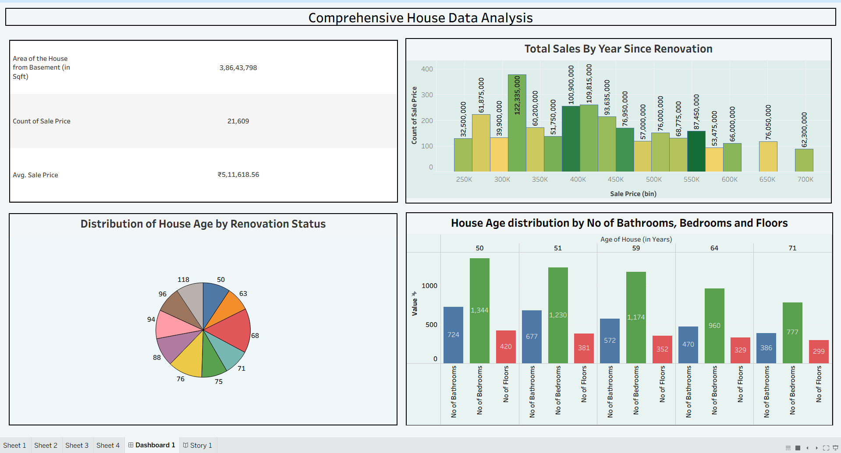

2. Story Overview
A Tableau story was created to present insights step-by-step.
Story Scenes:
Scene 1: Dataset Overview
Scene 2: Renovation Impact Analysis
Scene 3: House Age Analysis
Scene 4: Feature Distribution Analysis
Purpose:
To present housing market insights in a logical sequence.
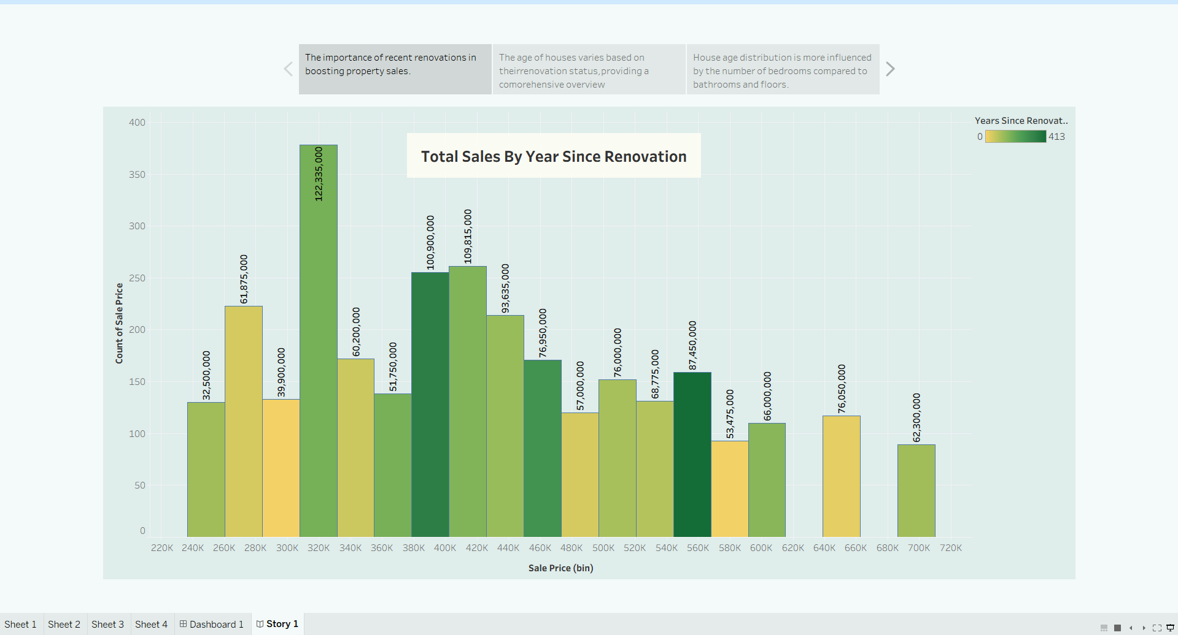
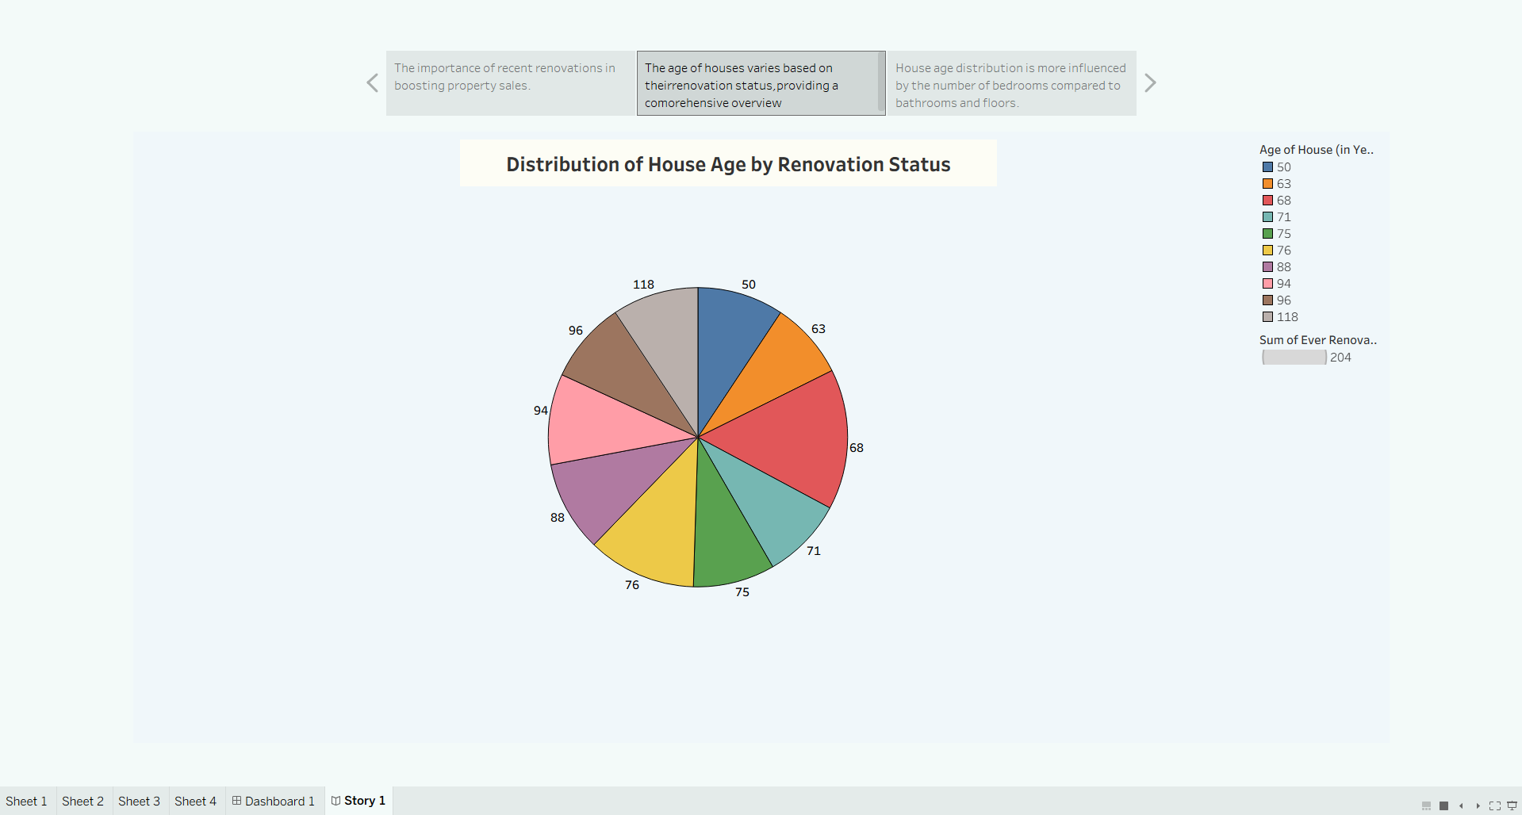
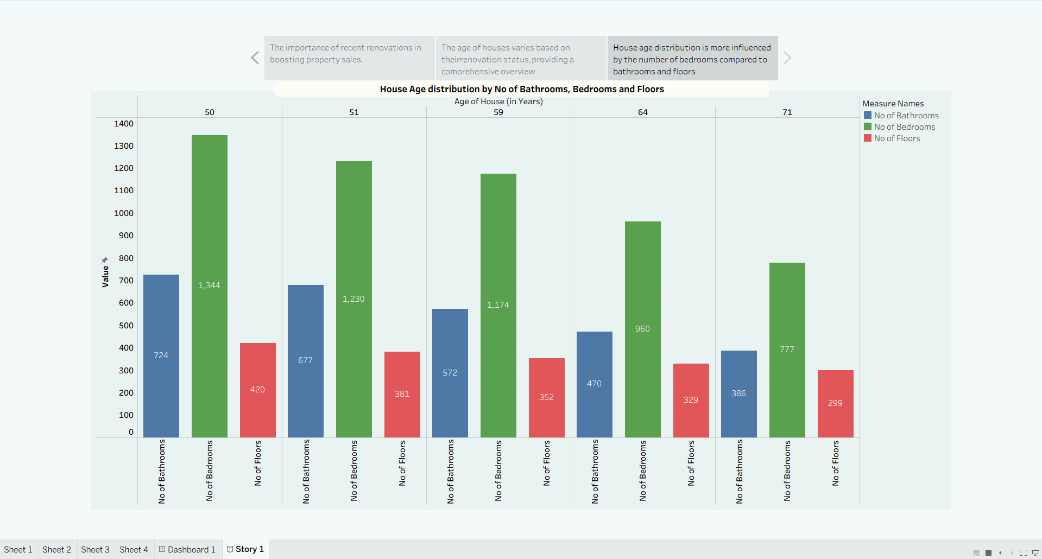

3. Tableau Public Links
Dashboard Link:
https://public.tableau.com/app/profile/srinu.vakada/viz/Project_17708262031760/Dashboard1?publish=yes
Story Link:
https://public.tableau.com/app/profile/srinu.vakada/viz/Project_17708262031760/Story1?publish=yes

